Marysville
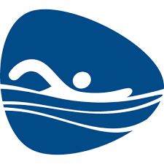
Girls’ Varsity Swim and Dive
Aug 8th Practice Begins MHS 4:00
Aug 24th Viking Relays HOME 10:00
Aug 30th Swim A Thon HOME 8:00
Sept 7th WWTower Relays AWAY 5:00
Sept 13th Lake Shore HOME 6:00
Sept 18th Marine City * HOME 6:00
Sept 20th Fraser HOME 6:00
Sept 22nd Alumni Meet HOME 12:00
Sept 25th Lakeview * HOME 6:00
Sept 27th Romeo HOME 6:00
Oct 2nd Ford II * AWAY 6:00
Oct 3rd ForSports Dive HOME 5:00
Oct 4th ForSports Swim HOME 5:00
Oct 8th Utica * HOME 6:00
Oct 12th MISCA Dive EMU TBA
Oct 13th MISCA Swim EMU TBA
Oct 16th Port Huron/PHN (Par/Sen Night) HOME 6:00
Oct 25th Dakota HOME 6:00
Nov 1st – 3rd MAC White Division Meet HOME 5:00/12:00
Nov 8th Regional Dive Cranbrook 5:00
Nov 16th -17th State Finals Div 3 EMU 12:00
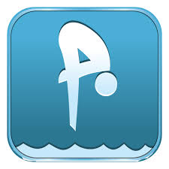
* Indicates MAC Blue Division
In order to compete at ForSports, MISCA and/or the State Finals, swimmers must meet a qualifying time standard.

